# TAKWatch

## Functionality

TAKWatch is a set of integration components for the TAK platform that allow the exchange of information between the ATAK application and selected GARMIN watch models.

The watch sends information about the battery status and the user's heart rate to ATAK, this data is sent to the server and can be displayed by other users.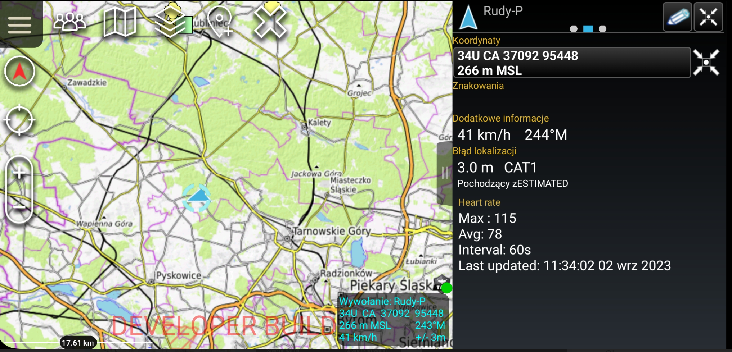

Selected types of markers, after being added in ATAK, are automatically sent to the watch.

The following markers and routes are currently supported.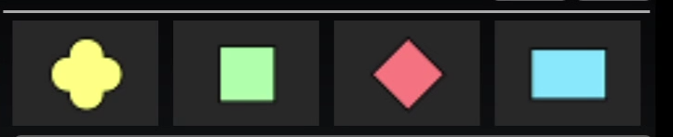

Additionally, the positions of all other users are sent to the watch.

NOTE: Markers are not stored on your watch when you close the app.

Additional options are available in the markers context menu. After holding down the option selected below, click on the watch icon.

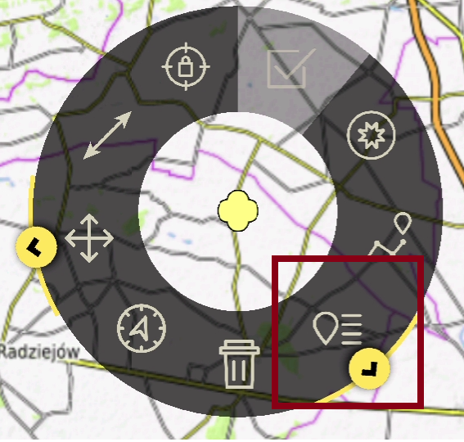 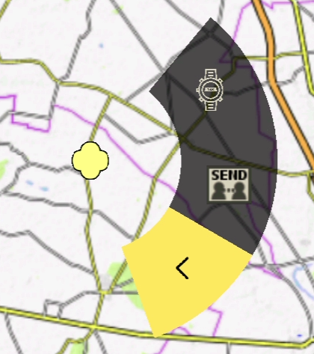

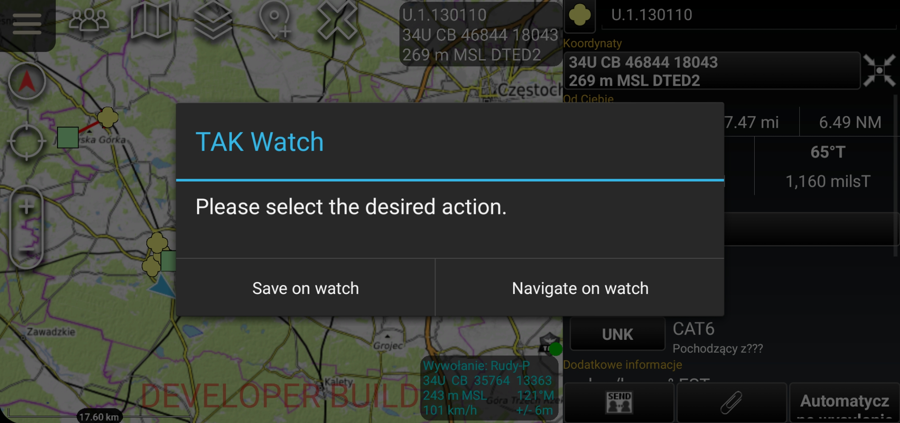

Two options are available:

* Save on watch

This option saves the marker as a waypoint in the watch's memory. It can be used in other applications on the watch.

* Navigate on watch

This option creates a vector from our position to the marker on the watch, and calculates the remaining distance.

## Preferences

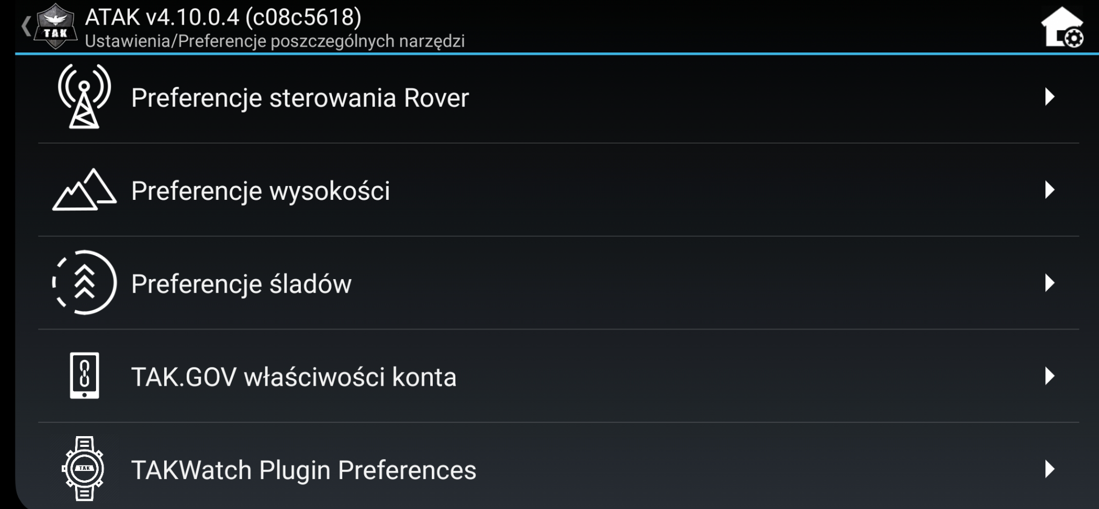

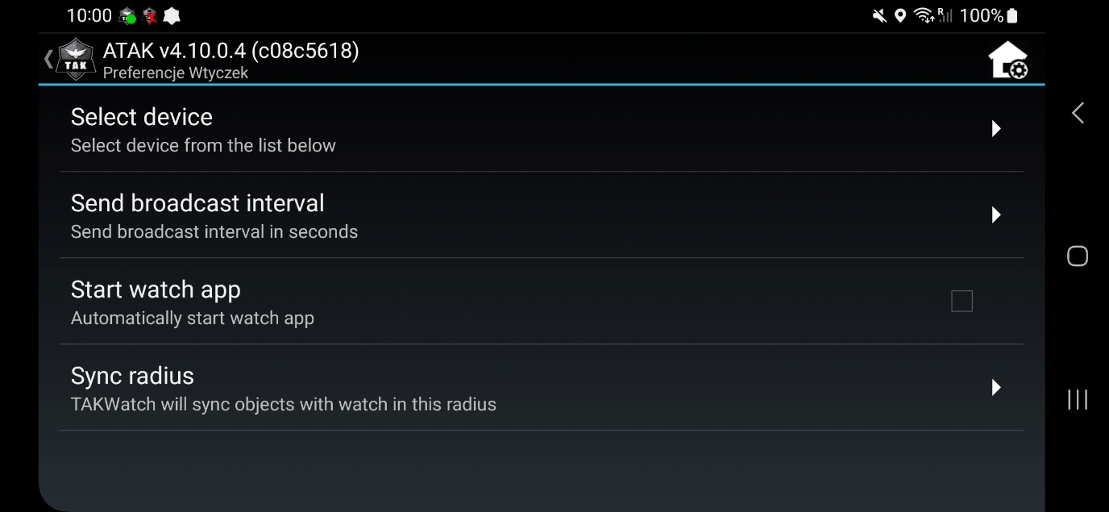

**1. Select device**

* Choosing a garmin device

**2. Send broadcast interval**

* Heart rate sending interval

**3. Start watch app**

* Automatically turn on the app on your watch after turning on the attack

**4. Sync radius**

* The radius within which the markers will be synchronized with the watch

## Garmin TAKWatch application screens

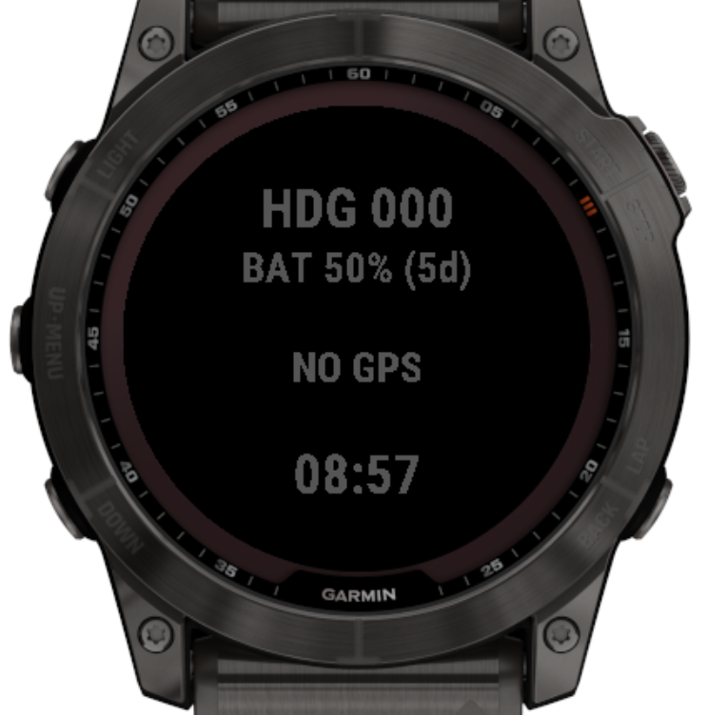

## Garmin TAKWatch app features

UP – Switch screens

DOWN – Switch screens

START/STOP – Vector cleaning

START/STOP – quick clicking – ALERT function – after starting ATAK, I will send information about the alert to everyone – Troops In Contact.

MENU (long press UP/MENU) - Opens the menu (markers, chat, settings)

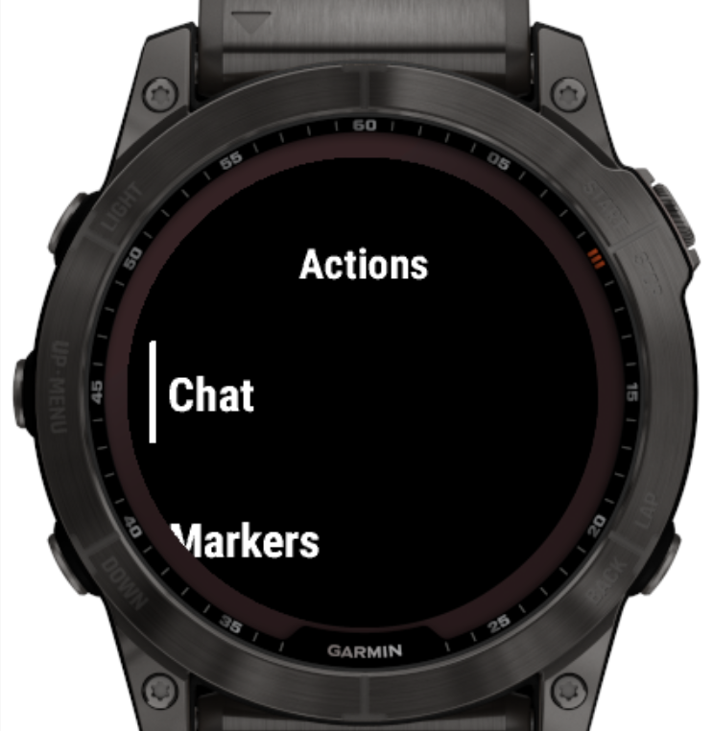

The following functions are available in the menu:

* Chat
  + The function allows you to send predefined messages to the All Messages channel in ATAK  
    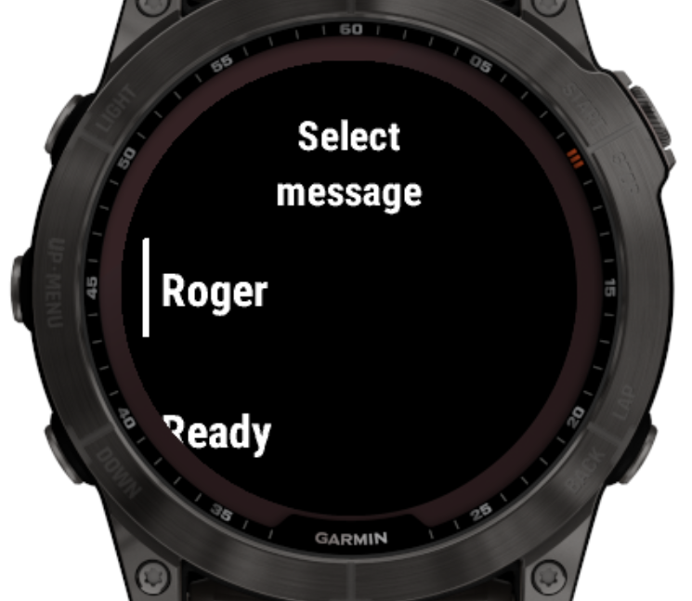
* Markers
  + The function allows you to browse the list of available markers

## Supported watch models

epix™ (Gen 2) / quatix® 7 Sapphire

epix™ Pro (Gen 2) 42mm

epix™ Pro (Gen 2) 47mm

epix™ Pro (Gen 2) 51mm

Forerunner® 945 LTE

Forerunner® 945

Forerunner® 955 / Solar

Forerunner® 965

fēnix® 5 Plus

fēnix® 5S Plus

fēnix® 5X / tactix® Charlie

fēnix® 5X Plus

fēnix® 6 Pro / 6 Sapphire / 6 Pro Solar / 6 Pro Dual Power / quatix® 6

fēnix® 6S Pro / 6S Sapphire / 6S Pro Solar / 6S Pro Dual Power

fēnix® 6X Pro / 6X Sapphire / 6X Pro Solar / tactix® Delta Sapphire / Delta Solar / Delta Solar - Ballistics Edition / quatix® 6X / 6X Solar / 6X Dual Power

fēnix® 7 / quatix® 7

fēnix® 7 Pro

fēnix® 7S Pro

fēnix® 7S

fēnix® 7X / tactix® 7 / quatix® 7X Solar / Enduro™ 2

fēnix® 7X Pro

# Technical details

## Communication

### Communication between the ATAK plugin and the application on the watch takes place via Bluetooth, the Garmin ConnectIQ API allows you to send simple types (string, int, but also Array<> and Dictionary (HashMap)).

### For communication in our implementation we use String[].

### Phone 🡪 Watch

The first element of the array is the type of message, the next elements are the appropriate data.

For example, after adding PLI to the map, the plugin sends the following message:

[marker, ANDROID-b336bf99b15fc0af, 50.681405, 18.6630171, HIPPY, a-f-G-U-C]

So for "marker" messages:

["marker", <uid>, lat, lon, title, CotType]

After removing a point in ATAK, the plugin sends a "remove" message to the watch:

["remove", <uid>]

Other message types are "waypoint" (sending points to save in the watch), "maparea" (setting the area visible on the map), or "vector" (setting a vector from our position to the marker.

### Watch 🡪 Phone

# After turning on the application, the watch sends a ["ready"] message to the plugin, which sends all MapItem objects from the plugin to the watch.

# When the HR sensor is working, it sends the message ["stats", <heart rate>, <battery>], this data is sent from ATAK to the server.

# Installation

## TAK Watch

## Download the .apk and install it in ATAK v 4.10

## TAK Watch IQ

We download .prg

We connect the watch to the computer with a cable

- Place the .prg file in the Garmin\Apps directory on the watch

## Error reporting

### TakWatchIQ

We send files from the watch - \Garmin\Apps\Logs\*

### TakWatch

We send output from logcat.